KMLG

(Kohinoor Maple Leaf Group)

**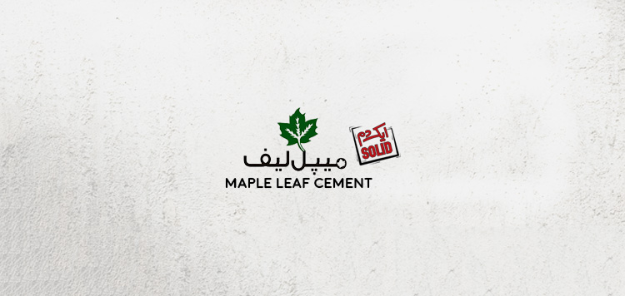

Project Report

|  |  |
| --- | --- |
| Course | Principles of Management |
| Instructor | Dr. Muhammad Shehryar Shahid |
| Group | 7 |

Introduction

History

The Kohinoor Maple Leaf Group was born from the trifurcation of the Saigol group of companies and is a reputable and leading manufacturer of textiles and cement. KMLG comprises of Kohinoor Textile Mills limited (KTML) and Maple Leaf Cement factory limited (MLCF). Saigol Group is a conglomerate group based in Lahore. It was started by Amin Saigol in Calcutta in 1930s who migrated from Calcutta to Faisalabad by the name of Kohinoor Industries Ltd. Currently it is being supervised by three Saigol brothers Tariq Saigol, Naseem Saigol and Taufeeq Saigol. Both companies are incorporated in Pakistan and are listed on three stock exchanges of the country. Maple cement was established in 1956, through a joint collaboration between government of Canada and West Pakistan Industrial Development Corporation (WPIDC) with a capacity of 300,000 tons clicker per annum. It is strategically located at Daudkhel (District Mianwali) in Northern Pakistan, which is an area rich in raw materials required for the production of cement. Kohinoor acquired the ownership and management of Maple Leaf Cement under the privatization policy of the government of Pakistan in 1992. Since the privatization of the company in 1992, the capacity of Maple Leaf to produce ordinary Portland cement (OPC) has increased from 1,000 tons per day (tpd) to a total capacity of 11,700 tpd. Its capacity to produce white cement has also increased from 100 tpd to 500 tpd, with the addition of a new plant. The Company has a production capacity of 10,700 tons per day for grey cement and 500 tons per day for white cement. This plant also has provisions for doubling of its productive capacity to 1,000 tpd. Over the years, the company added a production line using dry process technology, increased capacity while in 2006; it converted the existing wet process line to a fuel efficient dry process white cement line. In 2008, two existing lines of white cement 50 tons per day each were converted into an oil well cement plant and the company added a Waste Heat Recovery (WHR) plant in 2011. More than 55 percent of the Maple Leaf's shares are held by its holding company KTML, whereas 11.8 percent of the shares are held by general public and 22 percent are held by unspecified foreign investors. The logo of the Maple Leaf Cement is of huge importance. This Green maple leaf has been their identity since 1960. The Leaf takes its green color from Pakistan. This logo symbolizes integrity, strength and a commitment towards building a prosperous future. In 2013 they established a 24/7 toll free service center and in 2016 they initiated their own Supply Chain system to ensure timely delivery of quality cement. The textile industry of Kohinoor group comprise of two segments spinning and weaving. The initial capacity of its Rawalpindi unit comprised 25,000 spindles and 600 looms. Later, fabric processing facilities were added which increased spinning capacity. There are a total of nine units with 151,000 spindles capable of spinning a complete range of coarse and fine count yarn from natural and man-made fibers. Five units with around 85,500 spindles are at Rawalpindi and four units with around 65,500 spindles are at Gujjar Khan. The total production of yarn is 28,800,000 pounds annually. Currently there are 288 wide air jet looms in Raiwand mill which are capable of producing over 35 million linear meters of greige fabric per annum. Both divisions are modern facilities with state of the art machinery from Europe and Japan. The new addition to KMLG family is Maple Leaf Capital. Equipped with sophisticated analytical tools and strong ambitions, Maple Leaf Capital is set to create new standards in the capital investment arena.

**Product Portfolio and Clientele**

Presently Maple Leaf cement has 9% of the market share of OPC and is a leading brand in Pakistan with a diverse customer base. It is also the largest producer of White Cement in the country with 80% of market share. The Company produces various products, including Ordinary Portland Cement, Sulphate Resistant Cement, Low Alkali Cement and White Cement. The Company operates in two geographical areas, which include Asia and Africa. Its products are used for the construction of airports, runways and air bases, dams, barrages, waterways, residential complexes, high-rise buildings, highways and motorways. The Company exports its products to Afghanistan, Gulf States, South Asia, Africa, the Indian Ocean Island Republics and Central Asia. Grey Cement (OPC) is most commonly used for producing mortar and concrete and is one of the most important binders for building material worldwide. It is used in all types of construction, such as houses and buildings etc. Ideal for humidity, SRC is a special type of cement manufactured to contain a high content of iron oxide in order to limit the amount of the mineral phase tri calcium aluminate (C3A) and thereby increase its sulphate resistance. Maple Leaf’s Low Alkali Cement is of the highest quality available in Pakistan. It benefits concrete in resisting the alkali silica reaction and is primarily used in a construction that needs to be moisture resistant. Recently, maple leaf has introduced a new product known as “Wall Coat”. Beautifully lustrous and greatly economical, Wall Coat is the ideal solution for both exteriors and interiors. Unlike lime wash, Wall Coat covers a larger surface area, making it cost efficient. Its efficacy extends to its durability usage as primer, base coat and matt finish. It prevents seepage and has a cooling impact thereby lowering temperatures inside.